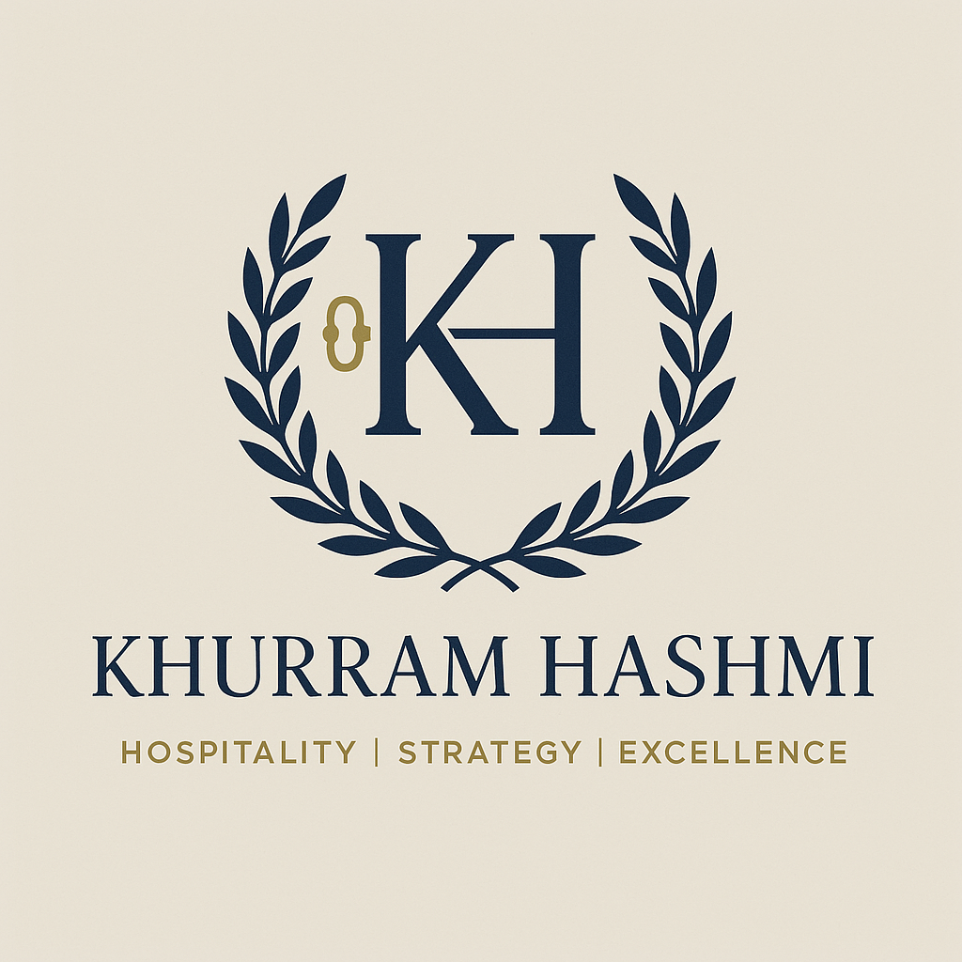**Meet Khurram Hashmi: The Maestro of Hospitality and Visionary of Experience**

**🔹 KH Monogram (Centerpiece)**

* **K and H** are designed in a classic serif font to symbolize *tradition, authority, and elegance* — ideal for the hospitality sector.
* They’re **intertwined** to show unity, leadership, and personal branding.

**🔹 Left Side of KH – The Keyhole Symbol**

* The golden **keyhole** integrated into the left leg of the “K” is subtle but meaningful.
* It symbolizes:
  + **Access** — to exclusive experiences, premium service, and strategic insights.
  + **Trust** — as in handing over the “key” to a project, property, or team.
  + **Discovery** — unlocking potential in people, places, and performance.
  + A nod to **hospitality**, where a key also signifies rooms, safety, and welcome.

**🔹 Laurel Wreath (Encircling Element)**

* Represents **excellence**, **honor**, and **achievement** — a timeless emblem of success in elite professions and leadership.

**🔹 Color Palette**

* **Navy Blue** = trust, intelligence, authority.
* **Gold** = prestige, success, luxury.
* **Beige Background** = warmth, approachability, subtle refinement.

From the rolling hills of Skardu to the bustling clubs of Lahore, Khurram is the name behind elegance, structure, and strategy in Pakistan’s hospitality landscape. A sharp-suited *General Manager*, a seasoned *consultant*, and a powerhouse *trainer*, he juggles resort launches, club events, restaurant chains, and even hospitality colleges — all before lunch.

Whether crafting luxury experiences in Dammam or breathing new life into Model Town Club’s gym, tennis courts, and swimming galas, he brings precision, passion, and polish. Clients trust him, colleagues admire him, and students learn from him.

With one foot in executive strategy and the other in grassroots training, he’s the rare leader who knows both the bottom line and the fine china. Oh — and did we mention? He’s also a thoughtful father, a celebrator of life’s big (and small) moments, and never far from the next great idea.

**🔹 LinkedIn Summary**

**Hospitality Leader | Resort & Club Consultant | Trainer | Strategic Business Developer**

I’m Khurram Hashmi — a results-driven hospitality expert with over two decades of experience leading premium clubs, hotels, resorts, and food industry projects across Pakistan and the Middle East. From launching 5-star properties in Skardu and setting up hospitality training programs in Dammam, to revamping urban clubs like Model Town Club Lahore, my strength lies in building high-impact operations with strategic foresight and customer-first culture.

As a Group General Manager, Consultant, and Lead Trainer with COTHM, I bring a unique blend of hands-on operational excellence, soft skills training, and business model innovation. Whether it’s managing multimillion-rupee projects, delivering keynote lectures, or creating unforgettable guest experiences — I deliver performance with purpose.

Let’s connect if you’re exploring opportunities in hospitality development, customer experience, or sustainable tourism ventures.

**🔹 Personal Website Bio**

**Khurram Hashmi – Elevating Experiences, Shaping Hospitality Futures**

Khurram Hashmi is a visionary in Pakistan’s hospitality and tourism scene — a multi-faceted leader whose journey spans high-end resort development, club management, and transformative training programs. Currently serving as Group GM for FMCG and Food Industry Projects, and a senior consultant for national and Middle Eastern hospitality ventures, Khurram is the engine behind seamless operations, elite training programs, and strategic expansion.

He has played a pivotal role in the growth of premier destinations like Model Town Club Lahore and resort properties in Skardu, while also spearheading academic initiatives through institutions like COTHM. With a sharp eye for customer experience, a deep understanding of club culture, and a relentless passion for innovation, Khurram continues to redefine what hospitality success looks like.

Off the job, he’s a proud father, thoughtful mentor, and someone who believes in celebrating people as much as profits.

**🔹 Pitch Deck Intro**

**About Khurram Hashmi**  
Hospitality is more than service — it’s strategy, structure, and soul. Khurram Hashmi brings all three. With 20+ years of leadership across elite clubs, resort hotels, and hospitality training institutions, he’s a powerhouse of operational expertise and business innovation.

From the pre-opening phases of boutique resorts in Skardu to corporate training programs in the Gulf, Khurram's insight turns properties into experiences, and teams into ambassadors. He’s your go-to consultant for customer-centric transformations, profitable hotel launches, and talent development with long-term impact.

**🔹 Professional & Visionary**

* **"Crafting Experiences. Leading Hospitality."**
* **"Where Strategy Meets Service."**
* **"Hospitality with Vision, Execution with Excellence."**

**🔹 For Consulting & Training**

* **"Building Hotels, Training Teams, Elevating Standards."**
* **"From Blueprint to Guestbook — I Make Hospitality Happen."**
* **"Empowering People. Perfecting Places."**

**🔹 Elegant & Personal Branding**

* **"Driven by Detail. Defined by Experience."**
* **"Hospitality is My Craft. Impact is My Promise."**
* **"Leading with Heart, Delivering with Precision."**